11/01
-
- Look for constructs already available as measures.
  - Identify multiple gaps and then pick one based on the measures
- Study methods
  - Literature Study - control variable are identified in the literature research
  - Quantitative Analysis
  - Qualitative Analysis
- CBIB (Community based Internal branding)
  - Google Scholar - (“Internal Advertising” or “Internal Branding”) and “Brand Communication” [be specific on what you are looking for and put words in quotes for efficient results)
  - Filter to specific language, region, location (filtering will help in drilling down to a particular paper)
  - Very important to cite/ quote in a research paper -> that shows data is validated otherwise its a game of assumption. The best way is to find literature surveys of the paper and related sources of it.
- Validity
  - Internal
    - Survey is more , Experimental is less
    - Refers to whether the manipulation of the independent variables or treatments actually caused the observed effects of the dependent variables.
    - Control of extraneous variables is a necessary condition for establishing internal validity
  - External
    - Survey is less, Experimental is more
    - Refers to whether the cause and effect relationship found in the experiment can be generalized.
    - To what population, settings, times, independent variables and dependent variables can the results be projected?
  - Measurement strategy
    - Constructs & Scale
      - If a scale exists, use it else create one by conducting experiments (control and experimental groups)
- Check out journal papers and what journals are getting approved
  - Read abstract of those papers
    - Find the type of research being currently done,
      - analyze the word cloud (prefer words are on the periphery, not in the center as 3-4 yrs from now, those words wouldn’t be relevant anymore)
- Term Paper (~Feb; Quantitative Analysis)

12/06
- For Thesis and Research
- opt for deductive (preferably). Inductive would be explanatory, requiring a lot of time and research to devise a theory on the data being available. Deductive is quantitative & Inductive is Qualitative
- It also aligns well with the mental model of cloning a proven theory and validating/ testing it.
- 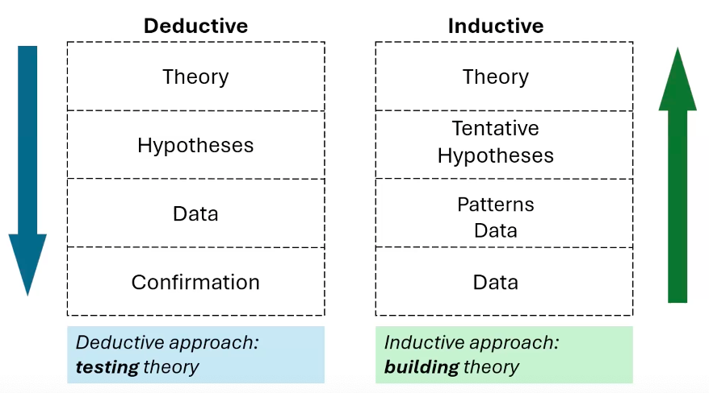
- SPSS Tool installation
- When presenting your equation for discussion - you can quote Cohen to demonstrate the significance of the dependent variables.
  - Weak impact - 0 - 0.2
  - Medium impact - 0.2 -0.5
  - High Impact - >0.5
- Std. Deviation is a better measurability of data dispersion. Not range of the data
- Important to have predictor variables on the same scale. Z scale is a good measure to have the variables at the same scale else you'll have a bias equation where one variable will be more impactful than other due to the range.
  - For financial modeling, there are different kind of scales utilized since the data is not linear. Logarithmic scales/ Geometric means. eg. Financial Modeling
- Degrees of Freedom - In statistics, when estimating - anything is calculated by fixating one value in the equation.
- Example Model -
  - https://docs.google.com/document/d/1cYvWu2XkVR_klJNXqq2zozpeFNlW3zEH43jlY6y3HTc/edit?usp=sharing
- 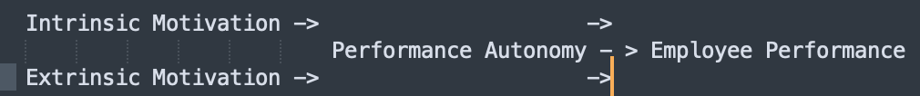

- Motivation-Performance Survey Form (Academic Survey) -
- https://forms.gle/26HMHwMqmWk2q9Ab8
  - Timing of the survey is very critical to make sure the responses are not biased. Impact of Seasonalitity.eg. After appraisal, the responses will be very different than before. Hence timing it in such a way should not impact the responses.
- ** Action Item - Build your own model and survey form on the finalized thesis topic.
- - Try to incorporate "Zombie Seat Hunter" Idea into the thesis topic for real world use case(since you are already working on it)

12/22
- Literature review would consume 80% of one’s time in Research.
- A sound literature review is the key
  - Build/propose your model
  - Identify the constructs(check if there are established constructs for you topic by referencing similar prior research)
  - Find measurement scales (check if prior thesis exist and measurement scales have been defined)
  - If above develops to be a survey, develop questionnaire
- Inclass Working Session - Downloaded the form inputs as an Excel file and performed data transformation(cleaning, encoding, eliminating etc) on it (Build your own model using ‘Zombie Seat Hunter’ Research Idea)
  - Recorded Session - Pwd : @c8b^m77
- Data Collection
  - Missing Data
    - First check MIssing Completely at Random (MCAR) by conducting t-test for missing and present values for every variable (passes if > 0.05)
    - If t-test fails, check Missing at Random (MAR) by doing logistic/ linear regression (depending on whether it is a categorical/linear variable) checking for p-values between variables (passes if > 0.05; if below then MNAR)
    - If Missing Not At Random (MNAR) - change the research design
  - 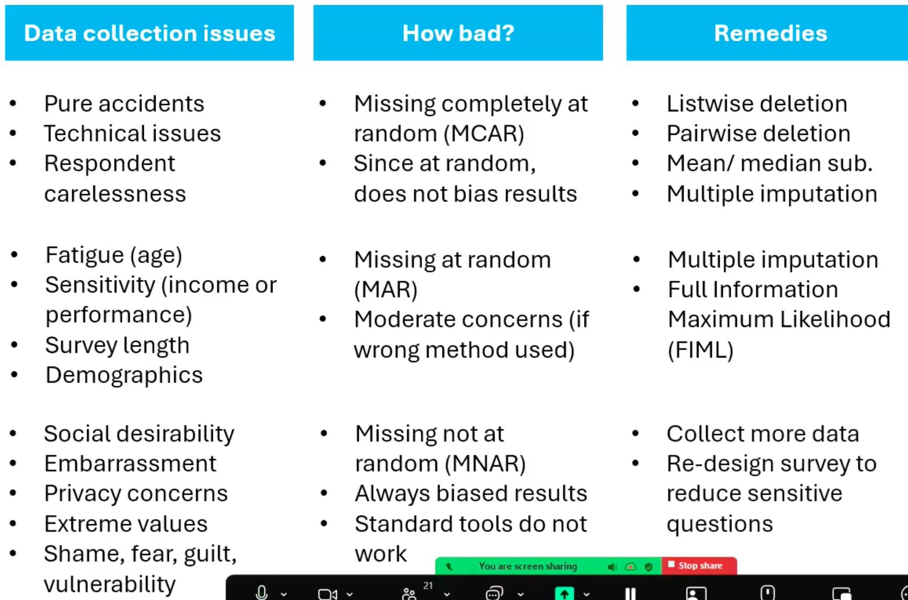
01/16:
-
- The distribution of sample mean
  - T : concept - if total data points 1000, take 30 at random and calc their means, repeat that for 500 times and you can plot a t graph with 500 means
    - Increasing sample size usually resolves most issues with distribution (Central Limit Theorem)
    - If sample size is very high, then chances of power (1 - Beta) being high is very low
    - Sample size (n) = (Z1 - a/2 + Z1 - b)square/ d-square

  - Z
  - F : Conduct F test when there are more than 2 categories/ groups in a variable. It helps identify which group is different. T is helpful when 2 groups.
  - X-square
- Type 1 error (Alpha) - when you reject status qou (null hypothesis) & Type 2 error (Beta) when you fail to reject alternative hypothesis
  - As Alpha reduces, Beta increases.
    - 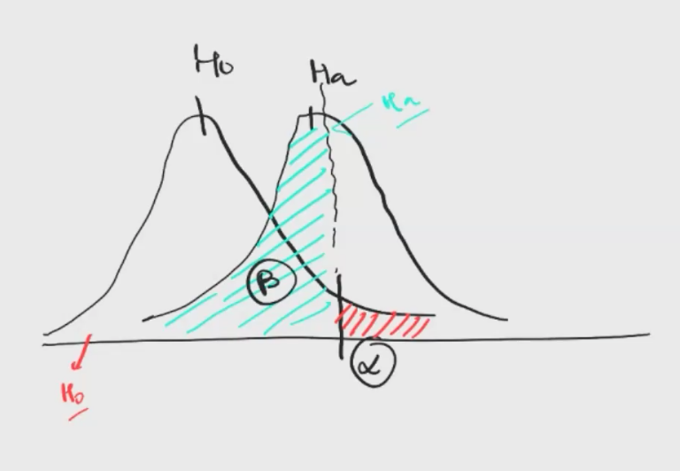
    - Alpha is in Null hypothesis, Beta is in Alternate hypothesis
    - Effect is the slope. (y = mx+c) Effect is “m”
    - Power of test(1 - Beta) is you are challenging the status quo and are statistically proving it right
      - 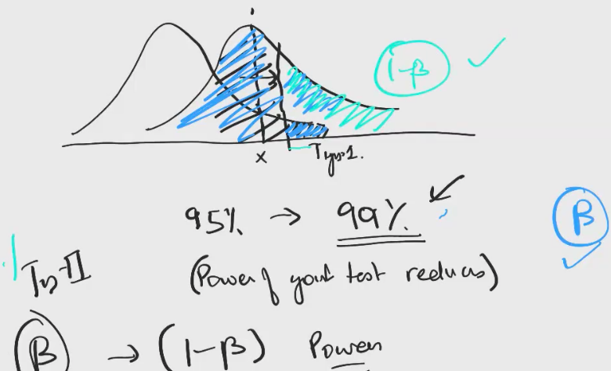
    - Generally, alpha is <= 0.05, power is 80% and sample size is around 200-400
      - There should be sufficient points for different groups (eg. Male, Female). You’ll observe this when there is polarity in recorded points between the two groups. Polarity is when one group’s mean is 3 and other groups 8 on a scale of 1 to 10.
- Hypothesis Testing
  - Be mindful of wordings used. (eg. instead of Accept, use ‘Fail to Reject’): reason being, the results may/ may not be accepted outside of your scope of analysis but within your scope of analysis, we know definitely that its failed to reject.
  - Type 1 error accepted by journals if it falls within <0.05 range (ie. 95% confidence)
- Steps when checking distribution
  - Set Up Alpha upfront (ie 0.05)
  - Set up acceptability probability region
  - Perform Hypothesis testing
01/30:
- Session 11-12: Saturday, Jan 17 Recording (with Passcode)

https://zoom.us/rec/share/VKXeuVeRE5V19aMIPLVxzCcNYOtKvgShoY90vkjspZK4ewJa8zE_odt5jF6SOkGz.72WP1eThEszfQ72y
Passcode: 65xrs!kG

Session is related to:
- Ethics Analysis Workshop in JASP
- Mean is impacted by extreme values, Median not so much
  - If there is difference between Mean and Median, there is polarity in data
- Shapiro-Wlk test shows the normality of the data. Ie normal distribution (>.99)
  - The normal curve does not describe our data - it is a reference showing what the data would look like if it were perfectly normal.
- Sample Central Limit Theorem
  - Distribution of the sample of means is closer to normal distribution as sample size increases. t- distribution tests can be used for such a distribution.
  - Bigger the sample size, better
- Significant Test of Difference:
  - T- test
    - Paired Sample t-test - done when there are two groups (eg. Control/ Experimental, Male/Female etc). Difference between the means of two groups and check whether the difference is significant. Pre and Post of same respondent within the group
    - Independent Standard t-test - Done when groups are independent. Two groups perform the tests at the same time but differently
  - Analysis of Variance (ANOVA) - done when there are more than two groups. It checks the means of the different groups. Atleast one group behaves differently. If there is only one dependent variable (DV), performing ANOVA test is preferred
  - Multivariate Analysis of Variance (MANOVA)[Pillai Test or Wilks test] - If more than one DV, performing MANOVA test is preferred. Performing separate ANOVA tests is avoided incase the DVs are dependent on each other, as it’ll create bias. Pillai Test or Wilks test are presented in the research paper usually.
  - Analysis of Co-Variance (ANCOVA) - More helpful to see the complete picture of how different variables are correlated and which ones are significant
- If the independent variables are highly correlated (ie >.7) then your model changes. Eg. Y = X1A + X2B + X3C + X4D and X3 is dependent on X4 and X2 and X1 is dependent on X3. (X2, X4)-> X3->X1->Y.
  - Literature Review will help you determine such correlations with Y, X’s and also identify the control variables
- Residuals
- Equality of Variance test (Levene’s test) - The variance between the different groups should be insignificant. That is when you can proceed with the t-test.
  - Question - Having a hard time understanding on what particular variables are these tests conducted
    - Is it X, is it Y, is it control variables?
    - Ans. Keep the question in front of you (In the case of this example, the question is ‘Was the workshop effective?’)

01/31:
Session 13-14: Saturday, Jan 17 Recording (with Passcode)

Link - https://zoom.us/rec/share/_OLAY-Ckt6k-s7C5UmjEYTTde4ZJFOERSjGbjHVXv_lK-IWEvBj8n_ZcgTjd50bm.XtYGpo99myZnCiGJ

Passcode: =py3v%#n

In this session, professor explains - what factors cause the dependent variable to change. And how to identify the effects of your research/ experiment on the experimental group. Whether it just impacted the experimental group or both (control group and experimental group). Were there any other factors (like Gender, Age etc) that could influence the effects. Was there a particular Gender, Age group within the experimental group that was influenced more than the same group in the control group etc.

The aim is to identify the plausibility of causal influence.

- For user - Feed the quantitative / qualitative papers(that the user likes) to an LLM. Ask it to generate some datasets based on its understanding for you to better understand how the research paper reached its conclusions
- Conduct a survey instead of setting up an experiment
  - surveys describe what is happening, while experiments explain why it is happening. The choice between them depends on the research question and the need for causal inference.
- Types of equations:
  - Regression: It is a cross sectional study (At a particular moment/period in time). Uses ordinary least squares (OLS)
    - Report B when a regression model (Unstandardized Coefficient)
  - Simultaneous Equation Modeling (SEM): Focuses on covariance. Helps you decide on the measurement model. Calculates Covariance observed and Covariance predicted. It consists of multiple linear equations such that the independent variable also have an equation of their own that can be used to formulate the final equation for the dependent variable
    - Limitations:
      - Misses omitted variables from the model. Omitted variable is a variable which can explain your variables of interest in greater detail which you missed because of which your model is not increasing the probability of causality
      - Reverse Causality
      - Selection Effect
    - Controlling for Endogeneity: When your model takes into account instrumental variables (variables that affect the predictor variables and not the dependent variables)
    - Report Beta when a SEM model (Standardized Coefficient)
  - Randomized Experiment

02/06
- Degrees of freedom
- 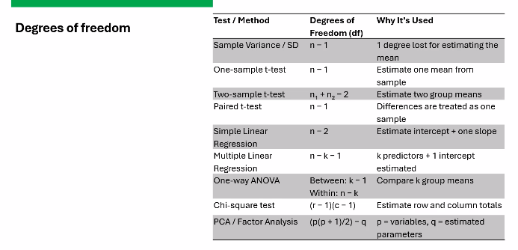
  - For Std. Dev. - If degrees of freedom is 39, then sample size is 40 as (n-1)
- Linear Regression Critical Assumptions:
  - Linearity (Good) : only for continuous variables
    - Residuals vs Predicted plot
  - Heteroscedasticity (Bad) : Variance of residuals across all levels of Independent Variable (IV) is not constant, its a problem!
    - Residuals vs Predicted plot
  - Independence of errors (Good) : Regression treats each row as one independent piece of information
    - Durbin-Watson Test [~2 Good, < 1.5 +ve autocorrelation, >1.5 -ve autocorrelation]
  - Normality (Good) : Residuals are normally distributed
    - QQ Plot
  - Important to make a graph between Residuals vs Predicted Values. (Helps us understand a lot of things about the data)
- Confounding Factors (Age, Gender, Firm_size etc)
- Model Fitness Test
  - R square value and F-test determines model fitness
- Term Paper needed to be submitted by 04/10 (2000 - 3000 words)
- Techniques:
  - T-test: helps identify signal vs noise (ie model vs chance)
  - ANOVA (Manova/ Ancova): helps identify signal vs noise (ie model vs chance)
  - Regression : helps identify signal vs noise (R square, F-test)
- Exploratory Factor Analysis (EFA)
  - 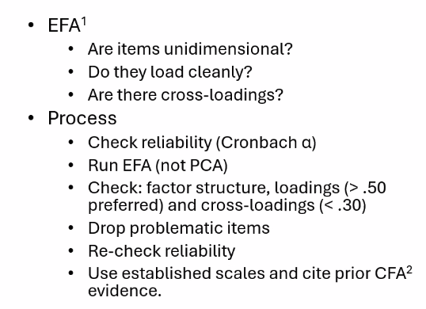
    - Helps determine the number of factors

